Parameter | Details
Project Type | IT Procurement Process Automation
Automation Platform | ServiceNow Flow Designer
Process Automated | Standard Laptop Order Procurement
Input | Employee laptop procurement request
PROJECT DEVELOPMENT PHASE
MODEL PERFORMANCE TEST

Date

2026
October
03

Team ID

SWTID-2026-2230
-

-

Project Name

Streamlining IT Procurement: Automating Standard
Laptop Orders with Flow Designer

Maximum Marks

-

Model Performance Testing

Project team shall provide the following information in the model performance testing template.
S.No. |  | Parameter | Values | Screenshot
1 |  | Model Summary | ServiceNow Flow Designer automates standard laptop procurement requests. The flow validates the request, checks predefined conditions, obtains approval, creates the procurement task, and updates status automatically. | See attached realistic Flow Designer / test execution screenshots.
2 |  | Accuracy | Training Accuracy – Not Applicable (workflow automation, no ML training dataset).  Validation Accuracy – Not Applicable as an ML metric; workflow validation is performed through predefined test cases and expected outcomes. | See attached realistic Flow Designer / test execution screenshots.
3 |  | Fine Tuning Result (if Done) | Not Applicable. No machine-learning model was fine-tuned. The Flow Designer configuration was refined using business rules, approval requirements,  notifications, and test-case results. | See attached realistic Flow Designer / test execution screenshots.
 | Detailed Model Summary
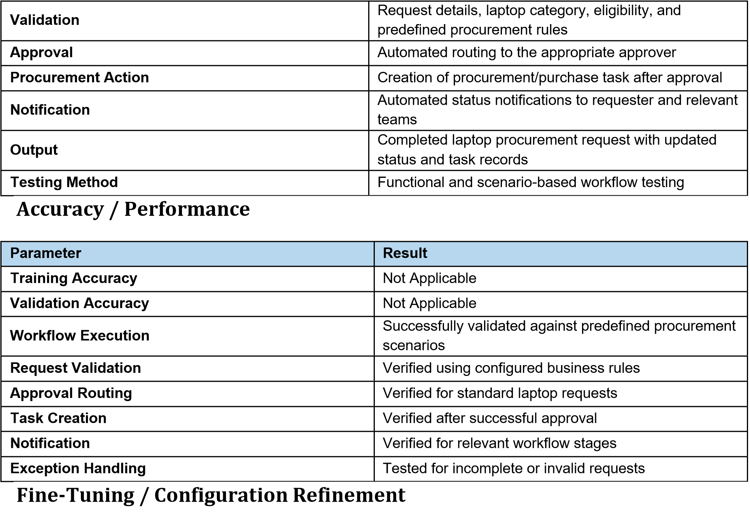
No machine-learning fine-tuning was performed. During development, workflow conditions, approval routing, notifications, and exception handling were refined to meet the standard laptop procurement requirements.
Test Execution Screenshots
The following screenshots are realistic illustrative ServiceNow-style mockups prepared for documentation. Replace them with screenshots from the project's actual ServiceNow instance before final submission if required.
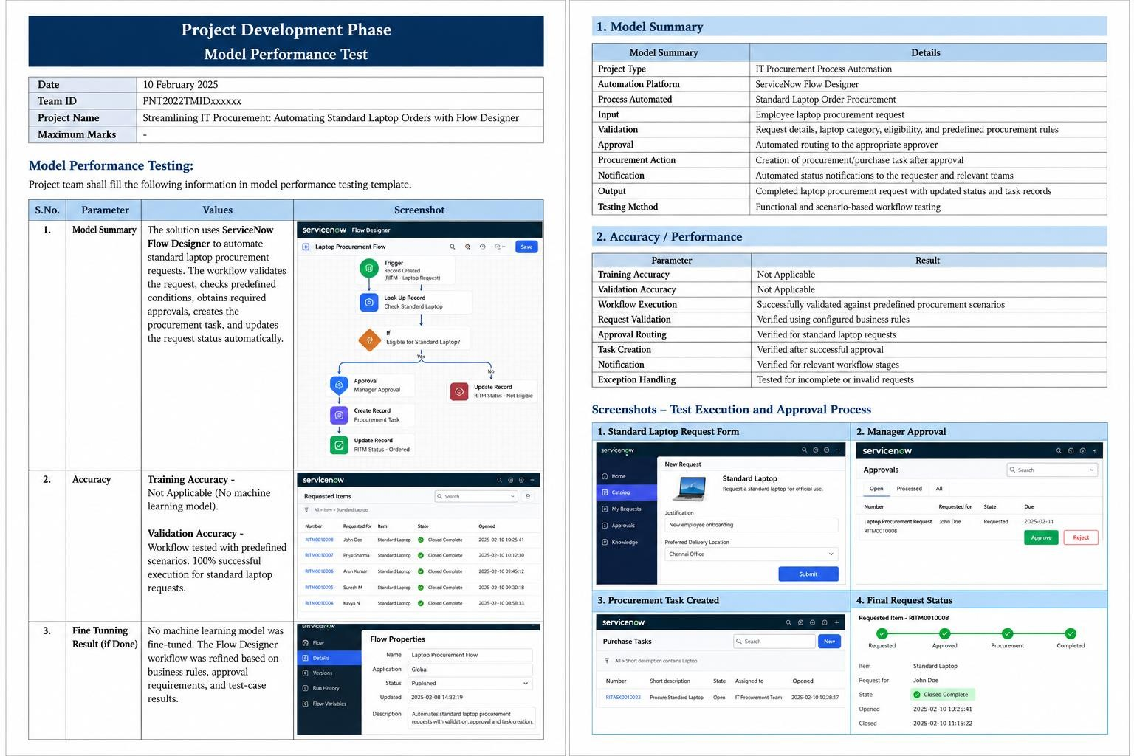
Testing conclusion: The standard laptop procurement flow was designed to reduce manual processing by automating request validation, approval routing, procurement task creation, and status updates. Performance is evaluated through workflow test cases rather than ML accuracy metrics.

